**FacebookWinFormsApp**

By: Shahar Sivilia 206375180, Benny Eyov 313566309

Class Diagram

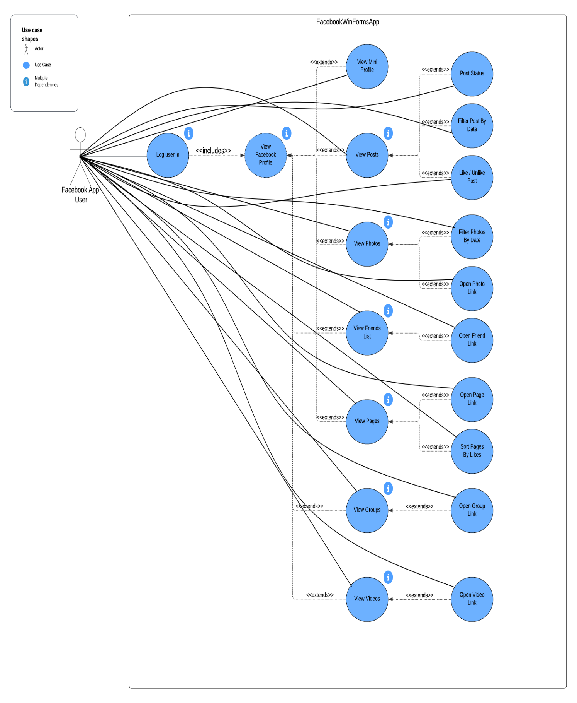Use Case Diagram:

New Features

Filter Posts By Date

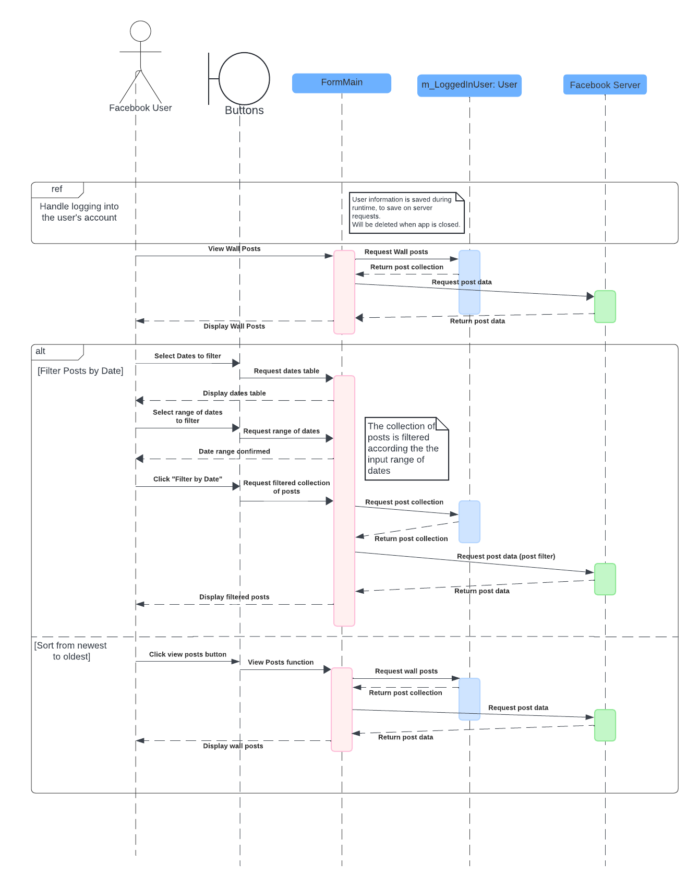The user selects a date range from the appropriate date picker buttons and once they press the "Filter By Date" button, the posts tab is refreshed and displays all posts within the selected range. This method is located in FormMain.cs at filterPostsByDate().

Sort Pages By Likes

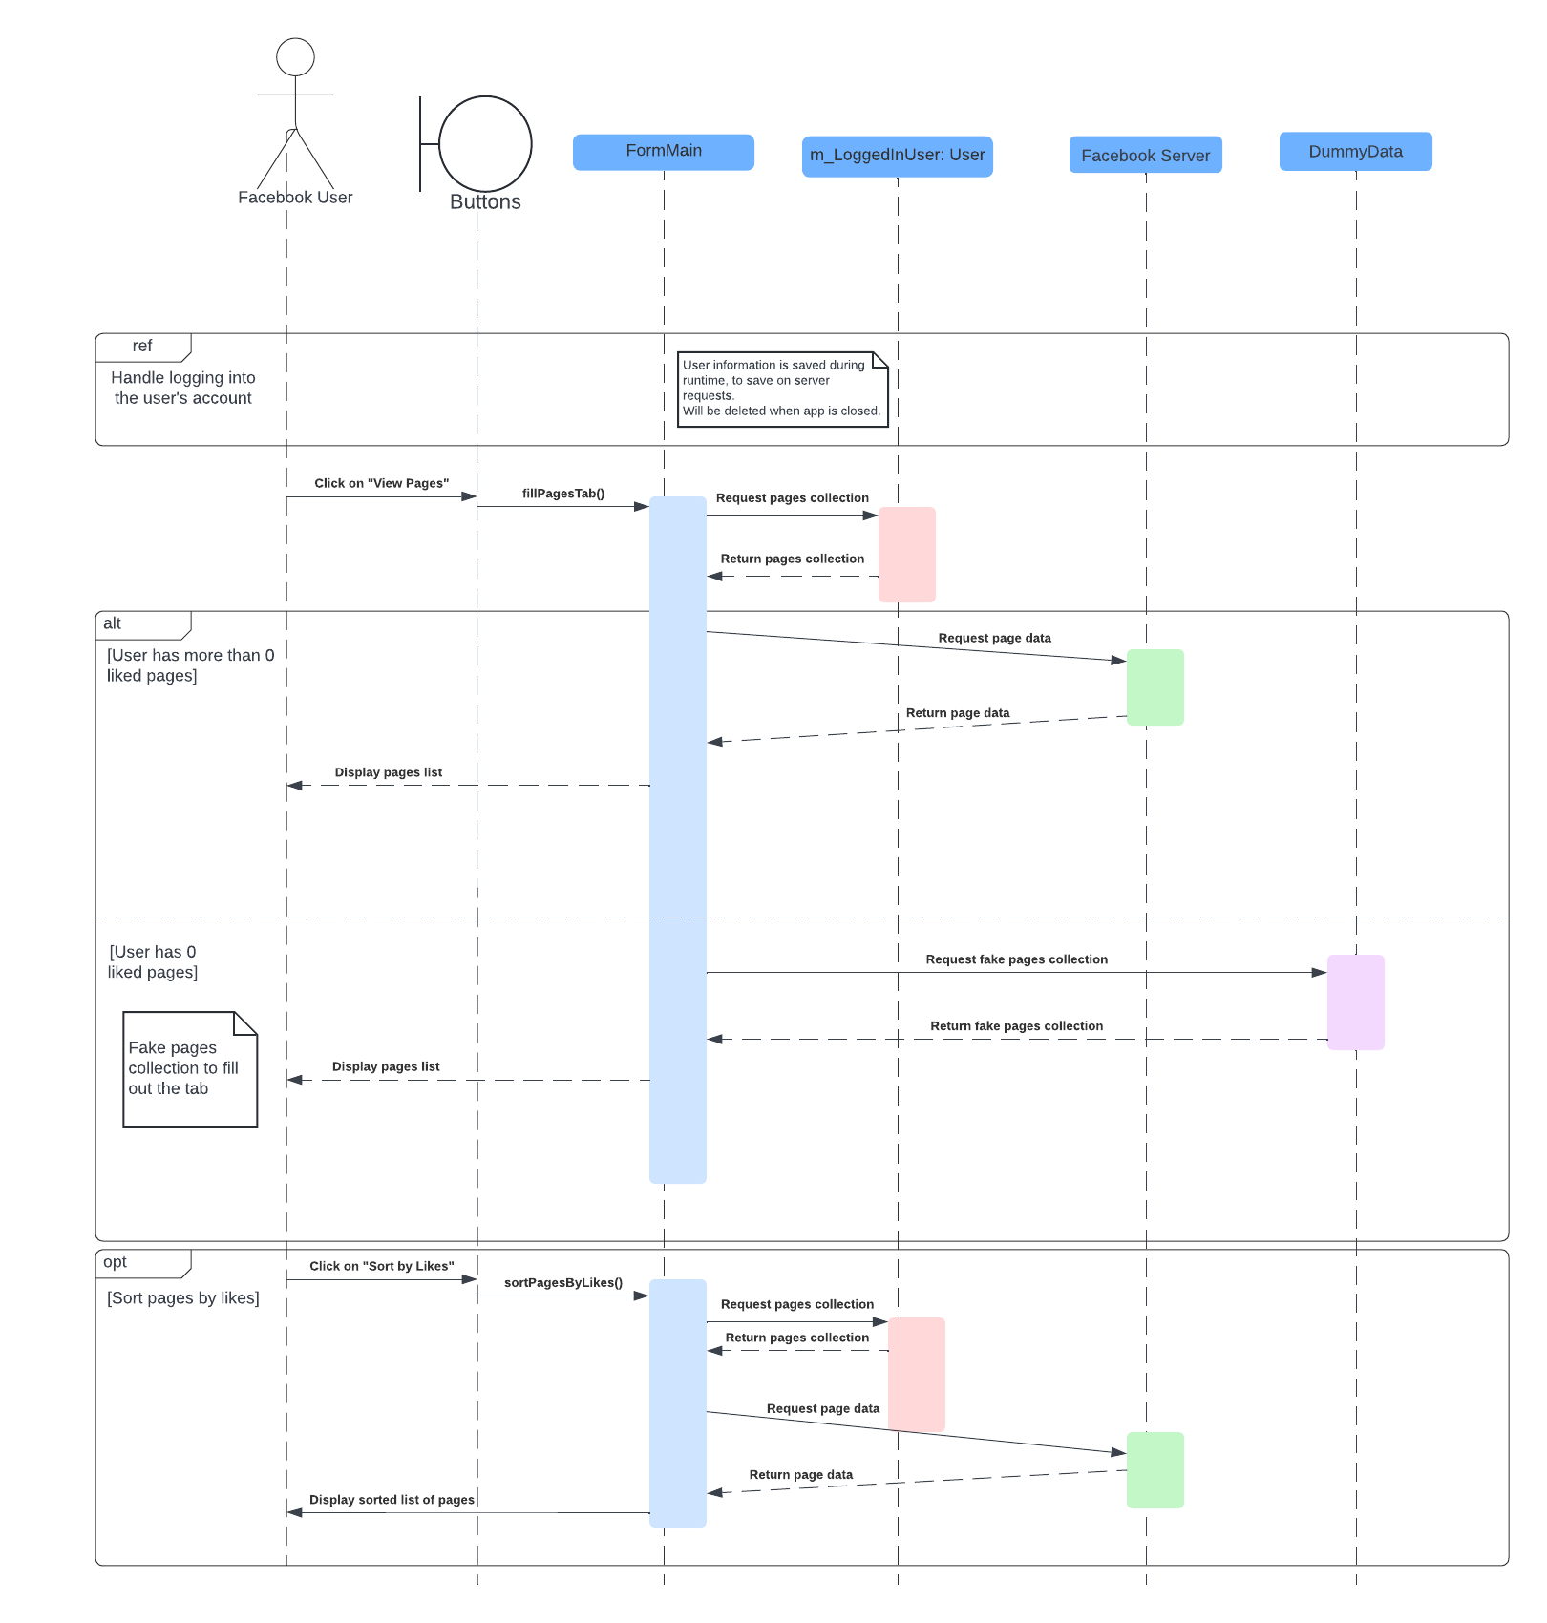Once the user presses the "Sort by Likes" button, the pages tab refreshes, and displays the user's liked pages based on the number of likes those pages have. This method is located in FormMain.cs at sortPagesByLikes().

**Diagrams Grade: 88**

**Grader Comments:**

**Use Case:**

- graph API not mentioned (-2)

**Class:**

- should not mention parts of the code which are not in

Use (-5)

- missing data members name and method return types

(-5)

**Sequence:**

Diagrams should show how your classes interact with each other as it pertains to your features. There are no classes in your code that handle logic, which means that there is no reason for the Sequence diagrams.